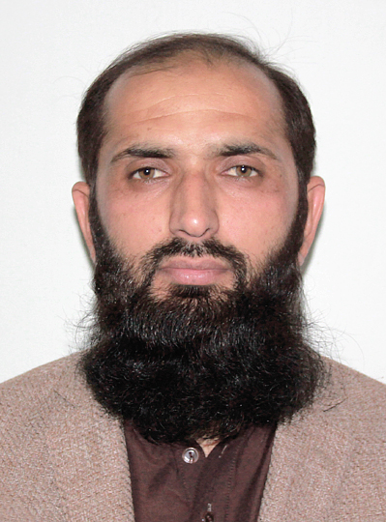
Dr. Inam ul Haq

Assistant Professor Islamic studies

Riphah International University Islamabad

Inamul.haq@riphah.edu.pk

Profile:
- Hadith and its Sciences, Islamic Studies (Quranic Studies, Fiqh-e-Islami), Arabic language and literature.

Educational Detail
PhD Islamic Studies (Hadith and Its Sciences), Sakarya University, Turkiye. awarded 2019. Dissertation Title: “Discussions of Hadith in Pakistan”
MPhil Islamic Studies, International Islamic University, Islamabad awarded 2013. Thesis Title: “The Issue of Humiliation in Pakistan, Reasons and its Solution in light of Sunnah.”
MA Islamic Studies, Sargodha University, Sargodha (2010)
MA (Dars-e Nizami) Wifaqul Madaris Alarabia Pakistan (2008)
B-Ed, Allama Iqbal Open University, 2010.
- Experience
Assistant Professor, Department of Islamic Studies, Faculty of Social Sciences & Humanities, Riphah International University, Islamabad, Pakistan, April 2021 – Present
Lecturer, Department of Islamic Studies, Faculty of Social Sciences & Humanities, NUML, Islamabad, Pakistan, Sept 2020-April 2021.
Visiting Lecturer at Iqra College, International Islamic University 2012-2013.
Associate Editor, Riphah Journal of Islamic Thoughts and Civilization. May 2022- Present
Translator (Turkish, Arabic, Urdu)/ Directorate General of Immigration, Sakarya, Turkiye. Sept 2018 to Nov-2019.
- Publication
- BOOKS
- Pakistan’da Hadis Tartışmaları, (Ankara: Türkiye Diyanet Vakfı, 2020).
ISBN: 978-625-7205-03-0. (Discussions of Hadith in Pakistan)
It is my PhD thesis which has been published by Turkish Diyanet Trust, Ankara.
- JOURNAL PAPERS
- Islamic Perspective on the Role of Family in Human Dignity (Arabic)
Acta Islamica, Volume.:10, Issue:2, July-Dec 2022 (HEC Approved in Y) ISSN 2411-7315
- Need of Scientific and Technical Skills for Preachers in Contemporary Era (Arabic)
Hazara Islamicus, Volume.:11, Issue:1, Jan-July 2022 (HEC Approved in Y) ISSN 2305-3283
- Irregular Hadith - A Comparative Study of Muhaddithin and Hanafi Jurists Views (Urdu)
Al-Idah Journal of Shaykh Zayed Islamic Centre, Pakistan. Volume: XXXVI, Issue: 2 (Dec 2018). (HEC Approved in Y) ISSN 2075-0307
http://al-idah.szic.pk/index.php/al-idah/article/view/14/5
- One of The Most Important Hadith Scholars of the 20th Century Indian Subcontinent Khalil Ahmad, Saharanpuri: His Life and Scientific Studies (Turkish)
The Journal of International Social Research. Volume: XI, Issue: 61 (Dec 2018)
www.sosyalarastirmalar.com Issn: 1307-9581
http://dx.doi.org/10.17719/jisr.2018.3003
- Shabbir Aḥmad ʿUthmānī And His Book “Fatḥ Al-Mulhim Bi Sharḥi Ṣaḥīḥ Al-Imām Muslim" (Turkish)
Journal of Sakarya University Faculty of Theology (SAUIFD), Volume: XX, Issue: 37 (June 2018). (ESCI indexed journal) ISSN 2146-9806 | e-ISSN 1304-6535 http://dergipark.gov.tr/download/article-file/490249

