**Dr. Muhammad Kashif Sheikh**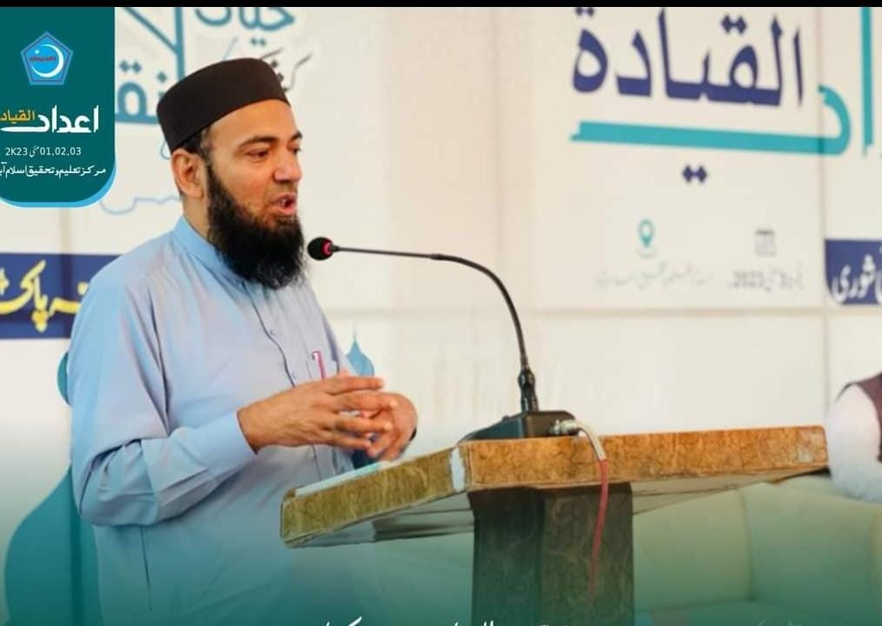

* **Associate Professor**, Islamic Studies, Faculty of Social Sciences & Humanities, Riphah International University,

Islamabad

* **Assistant Dean**, ORIC/RARE, Faculty of Social Sciences & Humanities, Riphah
* **HEC Approved Supervisor**
* **Contact: 03322207044 kashif.sheikh@riphah.edu.pk**

**Profile:**

Islamic Studies, Uloom ul Quran, Islamic History, Dawah and Islamic Culture, Fiqh and Islamic Finance

**Academic Qualification:**

* **Ph. D** (Islamic History) University of Karachi 2015
* **Masters** (Islamic Studies) University of Balochistan Quetta 1999
* **Shahada Al Aalamia** Rabita tul Madaris al Islamia Pakistan 1997
* **B. Ed** Allama Iqbal Open University Islamabad 2014
* **PGD** Professional Ethics and Teaching Methodology 2017

Riphah International University, Islamabad, Pakistan

**Experience:**

|  |  |
| --- | --- |
| Feb 2016  (Till Date)  Dec 2019  To Aug 2020  Dec 2016  To Apr 2020  14 Aug 2007  To  03 Dec 2012  2004 till  Date | Associate Professor, Department of Islamic Studies, Faculty of Social Sciences & Humanities, Riphah International University Islamabad.  Acting Dean, Faculty of Social Sciences & Humanities, Riphah International University Islamabad.  Head Department of Islamic Studies, Riphah International University, Islamabad  Program Coordinator (Curriculum & Examination)  Head Office, Jamiat ul Mohsanat Pakistan, Karachi.  Instructure of Islamic Sciences in Higher Studies at Madrassa and University Level  (Uloom ul Quran, Uloom ul Hadith, Fiqh (Islamic Law), Islamic Jurisprudence, Islamic Trade & Business, Fiqh al Muamlaat, Arabic Language and Literature, Professional Ethics at Riphah International University Islamabad, Jamia tul Ikhwan Karachi & Markaz Taleem o Tahqiq Islamabad. |

**Publications:**

**Book:**

* Ahkam-e-Rukhsat o Azeemat

(Being published by Shariah Academy international Islamic University Islamabad)

**Research Articles:**

1. Historical Background of Establishment of Dini Madaris in Sindh,

سندھ میں دینی مدارس کی ابتدا کا تاریخی پس منظر

Research Journal Islamic Studies, (ISSN: 1562-4773) Faculty of Islamic Studies, University of Karachi, January to June 2013 Page No. 225-237

1. Help of the Prophet SAW, Responsibilities of Muslim Countries and Governments.

نصرت نبی رحمت ﷺ مسلم ممالک اور حکومتوں کی ذمے داریاں

Dr Mahmood Ahmed Ghazi (R.A) Translated by Dr. Muhammad Kashif Sheikh from Arabic to Urdu Biannual Al- Seerah International, January 2014 Page No 359-373

1. Analytical Study of Curriculum of Deeni Madaris in Pakistan,

پاکستان کے دینی مدارس کے نصاب درس کا مطالعہ

Maarif Research Journal, Islamic Research Academy Karachi, ISSN Online: 2415-2315 Print: 2221-2663, Issue 14, July-Dec 2017, Page No 35-60 **[HEC Category: Y]**

1. A Critical Study of Deeni Madaris and their Curriculum,

دینی مدارس کا نصاب درس، تاریخی حقائق اور تقاضے

Majallah-e- Talim o Tahqiq, (ISSN Online: 2618-1355/Print: 2618-1363) Issue: 1, Vol: 1, Date: 31-03-2019 Jan-Mar 2019, Page: 23-41 **[HEC Category: Y]**

1. Teaching Trends of the Quran in Traditional and Non Traditional Institutions, a Comparative Study, تدریس قرآن حکیم کا مروجہ اسلوب، روایتی و غیر روایتی دینی اداروں کے رجحانات کا تقابلی جائزہ

Biannual Al Tafseer Karachi, ISSN: Print 1816-5389 Online: 2707-6911, July-Dec 2019, Page: 124-145 **[HEC Category: Y]**

1. Spread of Islam in Sindh in the Light of Historical Facts, an analytical study,

سندھ میں اشاعت اسلام، تاریخی حقائق کی روشنی میں ایک تجزیاتی مطالعہ Majallah-e- Talim o Tahqiq Islambad (ISSN Online: 2618-1355/Print: 2618-1363) Issue: Jan-Mar 2020, Page: 23-41 **[HEC Category: Y]**

1. Limitations for Disciplining the Children in the Light of Islamic Sharia,

حدود تأديب الأطفال فى ضوء الشريعة الإسلامية

Al Basirah, Department of Islamic Studies, NUML, Islamabad, (ISSN: 2520-7334, Print: 2222-4548) Vol: 9, Issue: 1, Page: 67-83, June 2020. **[HEC Category: X]**

1. A Research Study of the Methodology of Pir Mehr Ali Sha in Saif-e-Chishtiyai,

سیف چشتیائی میں سید پیر مہر علی شاہ کا اسلوب و منہج: ایک تحقیقی مطالعہ

Research Journal Al-QamarLahore, ISSN (Print): 2664-438X ISSN (Online): 2664-4398, Vol: 3, Issue: 1, January-June 2020(30-06-2020) Page: 233-244 **[HEC Category: Y]**

1. Legal Maxims and Standards of Lawful (*Halāl*) and Unlawful (*Harām*) Food: An Analytical Review in the Perspective of *Halāl* Certification,

غذا میں حلت و حرمت کے معیارات اور قواعدِ فقہیہ (حلال سرٹیفکیشن کے تناظر میں تحقیقی مطالعہ)

Majallah-e- Talim o Tahqiq Islambad (ISSN Online: 2618-1355/Print: 2618-1363) Issue: July-Sep 2020, Page: 25-46 **[[HEC Category: Y]**

1. Eradicating Gender-Based Violence against Female-Intimate Partner in Pakistan: A Theoretical Framework from Islamic Philosophy, Academic Journal of Interdisciplinary Studies, UK ISSN: E 2281-4612, 2281-3993, Vol 10 January 2021, P: 340- 356 **[HEC Category: X]**
2. Da’wah Insights from Surah Al .Furqan: With a Special Reference to Tafhim ul Quran,

سورہ الفرقان کی روشنی میں دعوت کا حکیمانہ اسلوب، تفہیم القرآن کا خصوصی مطالعہ

Majallah-e- Talim o Tahqiq, Islambad (ISSN Online: 2618-1355/Print: 2618-1363) Issue: Oct-Dec 2020, Page: 118-132 **[HEC Category: Y]**

1. Character Building in Educational Institutions: An Analytical Study of the Recommendations of the Council of Islamic Ideology Pakistan,

درس گاہوں میں کردار سازی کا پہلو: اسلامی نظریاتی کونسل پاکستان کی سفارشات کا تجزیاتی مطالعہ

Journal of Islamic Sciences, Vol: 3, 2020, P: 251-274, ISSN Print: (2617-9075) E: 2707-7470 **[HEC Category: Y]**

1. The Concept of Hereafter among the Quranic Verse froms **the *Mu’tazila,* the *Murje’ah* and the *Pervezia***,

تصور الاخرۃ عند المعتزلۃ و المرجئۃ و البرویزیۃ خلال الایات القرآنیۃ

Majallah-e- Talim o Tahqiq Islambad (ISSN Online: 2618-1355/Print: 2618-1363) Issue: Jan-Mar 2021, Page: 175-189 **[HEC Category: Y]**

1. Analytical Study of Deeni Madaris in Pakistan in the Context of National Educational Policies

پاکستان کے دینی مدارس : قومی تعلیمی پالیسیوں کی روشنی میں تجزیاتی مطالعہ

Maarif Research Journal, Islamic Research Academy Karachi, ISSN Online: 2415-2315 Print: 2221-2663, Issue 14, July-Dec 2020, Page No 15-36

1. Hate Speech And Ridiculing Islam: An Overview In The Context Of Freedom Of Expression, Journal of Positive School Psychology, **ISSN:** 2717-7564, Online: **2717-7564**, Vol. 7, No. 1, 2023, Page: 1233-1250 **[HEC Category: X**