BRIG (RETD) PROF DR. AKBAR WAHEED, SI (M)

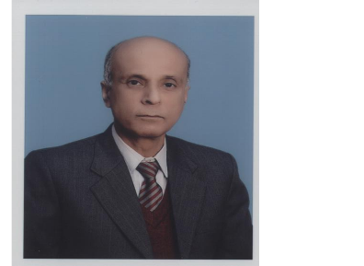

Qualification: MBBS, MPhil, PhD. CHPE

Teaching Experience: With effect from 14 Apr 1987 to date as Demonstrator, Assistant Professor, Associate Professor & Professor.

Courses Taught: MBBS, BDS, M Phil, PhD, FCPS and Nursing.

Supervisor: Approved for M Phil, PhD, FCPS.

Publications: 66 (in approved HEC & PMDC Medical Journals).

Conference/Workshops &
Seminars attended: 50
Presentations: 4
PG trainees Supervised: M Phil : 40
PhD : 08

PG trainees under- MPhil : 04
Supervision: PhD : 06
FCPS : 02

Membership Professional Bodies:-

  - Member Drug Appellate Board Ministry of Health Services Islamabad.
  - Member Pakistan Pharmacological Society.
  - Member PSF Technical Committee on Medical Sciences.
  - Member Technical Advisory Committee PMRC

Area of Research:- Pharmacology & Therapeutic / Medicinal plants

