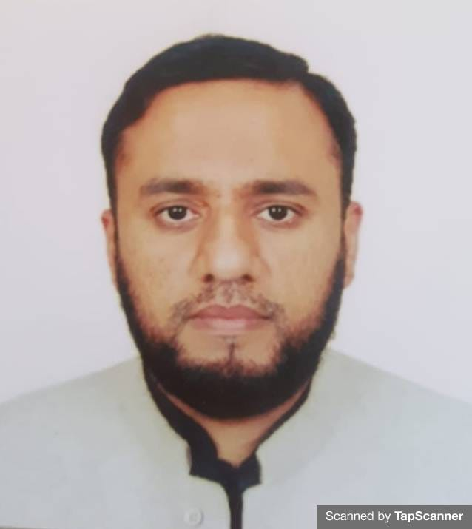
Dr. Zabih ur Rahman

Assistant Professor

Ph. D. Islamic History & Art, Dokuz Eylul University Izmir, Turkey

HEC Approved Supervisor

zabih.rahman@riphah.edu.pk

Contact # 03345346454

Subject Specialty:

Islamic Studies, Tafseer & Qur’anic Studies,,

Islamic History and Art

Personal Detail
- Education
Ph. D. Islamic History & Art, Dokuz Eylul University Izmir, Turkey 2019.
Dissertation Title: “The conquest and Islamaization of the Sind region (AH 15-415/AD 636-1024)”
Mphil in Islamic Studies, (Specialization in Tafseer and Quranic Sciences) International Islamic University Islamabad, awarded 2010.
Shahadah Al-Aalamia, Wifaq ul Madaris Salafiyya, Faisaabad, Pakistan, awarded 2004.
- Experience
Visiting Lecturer, University of Haripur, Department of Religious and Islamic studies, (Sept -2019 to Sept -2020).
Adjunct Faculty (Assistant Prof), Pak-Austria Institute of Applied Sciences and Technology Mangg Haripur. (Oct -2020-Oct- 2021)
Assistant Prof, Riphah International University Islamabad, Department of Islamic Studies, Faculty of Social Sciences and Humanities. (Currant job from Feb 2021)

- Publications

Research Papers:

- الجانب الحديثي و أثره في فهم القرآن و تفسيره – كتاب أحكام القرآن لابن العربي المالكي– أنموذجا
(دراسة تحليلية إستقرائية ), İslami İlimler Dergisi, Ocak/2018, Cilt: 13, Sayı: 1, ss.142-170.
- “Early Muslim Relations with İndus Valley and the Expeditions During the Guided Caliphate Period”, Dokuz Eylül Üniversitesi İlahiyat Fakültesi Dergisi, 2018, Sayı: 47, ss. 323-346.
- “Bilâdü’s-Sind’de Bir Arap Hanedanlığı: Hebbârîler (An Arab Dynasty In Sindh Region: Habbaris )(H.247-416/M.862-1026)”, Mesned İlahiyat Araştırmaları Dergisi, 2020, Cilt: 11, Sayı:1, ss. 135-164.
- ‘The History of Sindh from Islamic Conquests to the Arrival of the Conqueror of Sindh: An Analytical Study”, Journal of Islamic & Religious Studies University of Haripur, July-Dec/2020, Vol 5, No/2, Pp. 37-54
- “The Conquest And Islamization Activities Of Muhammad B. Qasim (D. 96/715), The Conqueror Of Sindh, In Sindh Region”, İhya International Journal of Islamic Studies, Turkey 2021, Vol: 7, No:1, Pp. 398-419.
- Languages:

1: Arabic
2: English
3: Turkish

