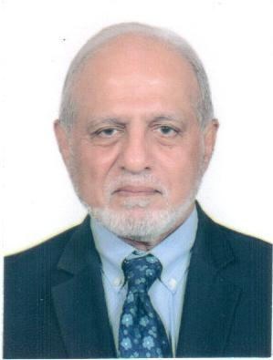
Lt Gen Azhar Rashid, (Retd), HI(M) MBBS, FCPS(Surgery), MHPE, MSc, PGD (PE & TM)
Dean FHMS/Principal, IIMC
Lieutenant General Prof. Dr. Azhar Rashid (Retd) HI (M), MBBS (KEMC), Diploma Surgery (AFPGMI), FCPS Surgery (CPSP), MHPE, M.Sc. Defence & Strategic Studies (National Defence University), is an eminent Cardiac Surgeon, who after joining Army rose to become Surgeon General/ Director General Medical Services of Pakistan Armed Forces. He graduated from King Edward Medical College in 1979 and on joining the Armed Forces did Diploma in Surgery in 1980. After his initial training, he did FCPS in Surgery in 1986 and after that he got advanced training in Cardiac Surgery at Saint Thomas and Guys Hospital, London UK from 1988-1990. In his academic pursuits at AFIC/NIHD, he rose from Registrar to Professor in Cardiac Surgery, and has authored more than “30” articles in national and international journals. He has been member and later secretary of faculty of Cardiac Surgery at College of Physicians & Surgeons Pakistan (CPSP) from 1998 till 2005. He also supervised post graduate training of several Cardiac Surgery trainees. He was Commandant & Executive Director at AFIC/NIHD 2006 to 2008. In 2009 after successfully completation of his M.Sc in Defence & Strategic Studies from National Defence University, he was appointed as Director General Surgery till 2011 and then Surgeon General / Director General Medical Services the ultimate position in Armed Forces Medical Corps a position in which he served till May 2015. He was awarded Hilal-i-Imtiaz (Military) in recognition of his meritorious services and the illustrious military career. He joined Islamic International Medical College (IIMC) as a Dean FHMS /Principal, IIMC in 2017. In 2021 he successfully completed his MHPE degree from Riphah International University. In 2022 successfully completed his Postgraduate Diploma in Professional Ethics and teaching Methodology from Riphah International University.
Area of Research: Medical Education & Cardiac Surgery

